Jyle Darling

M093437

APPLICATION test cAses

AT2-SPRINT 3

Table of Contents

Test Cases 1

Test Case Images 2

# Test Cases

Tester Jyle Darling.

|  |  |  |  |  |
| --- | --- | --- | --- | --- |
| **Test Case** | **Description** | **Expected Result** | **Actual Result** | **Comments** |
| 01. | Creating a new admin account while verifying password requirements. | New admin account only created when password requirements are met. | As expected. | Ref figure 1 and 2. |
| 02. | Rating a movie multiple times to see rating changing | Rating an unrated movie should bring it to the top of the rated movies table | As expected. | Ref figure 3 and 4. |
| 03. | Viewing top ten rating chart, opening another page to rate a movie while rating page updates automatically. | Rating chart to be displayed an updated every 5 seconds. Changing the rating will alter the chart on the refreshing page. | As expected. | Ref figure 5, 6 and 7. |

# Test Case Images

Figure 1.

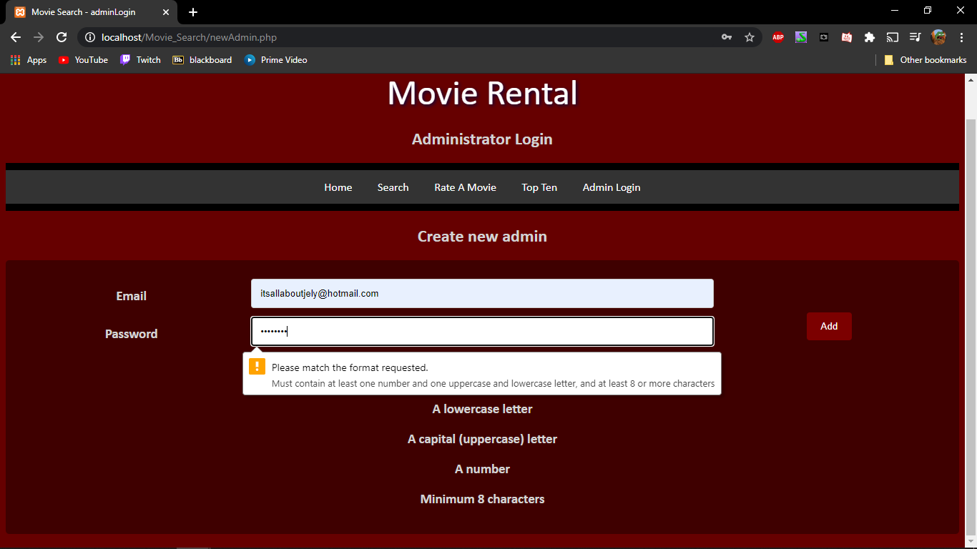

Figure 2.

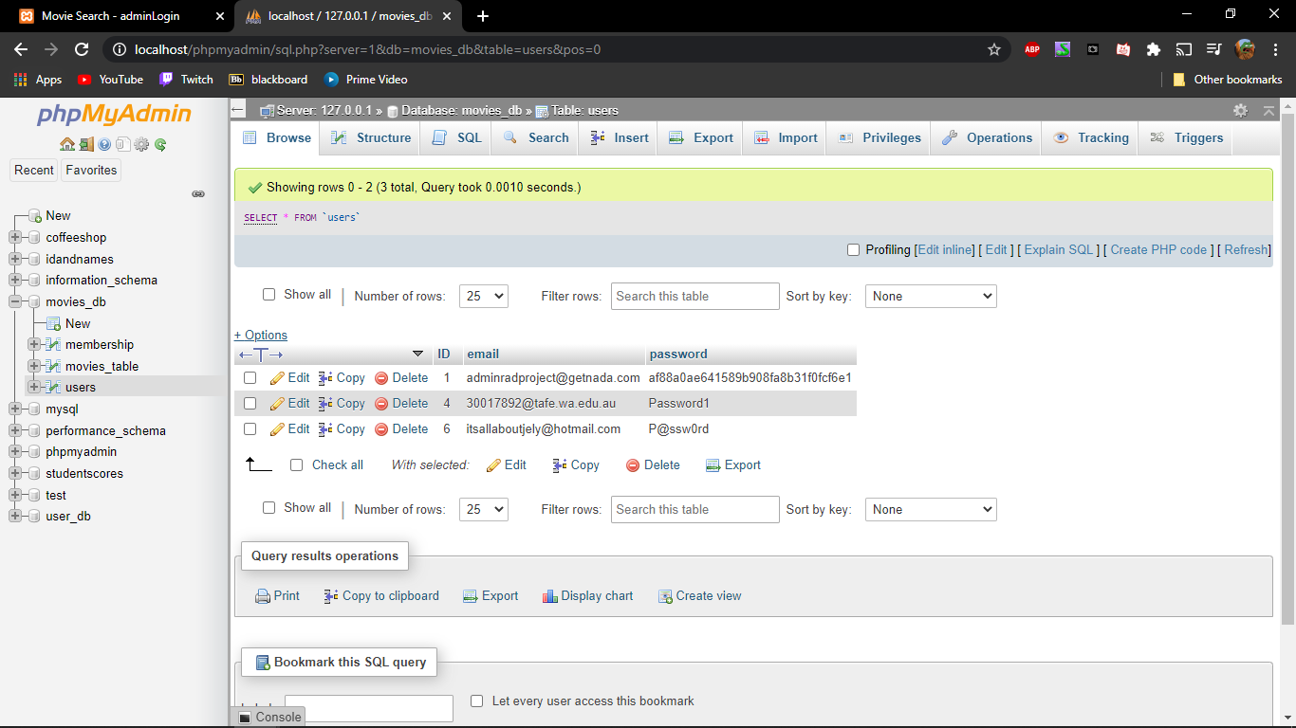

Figure 3

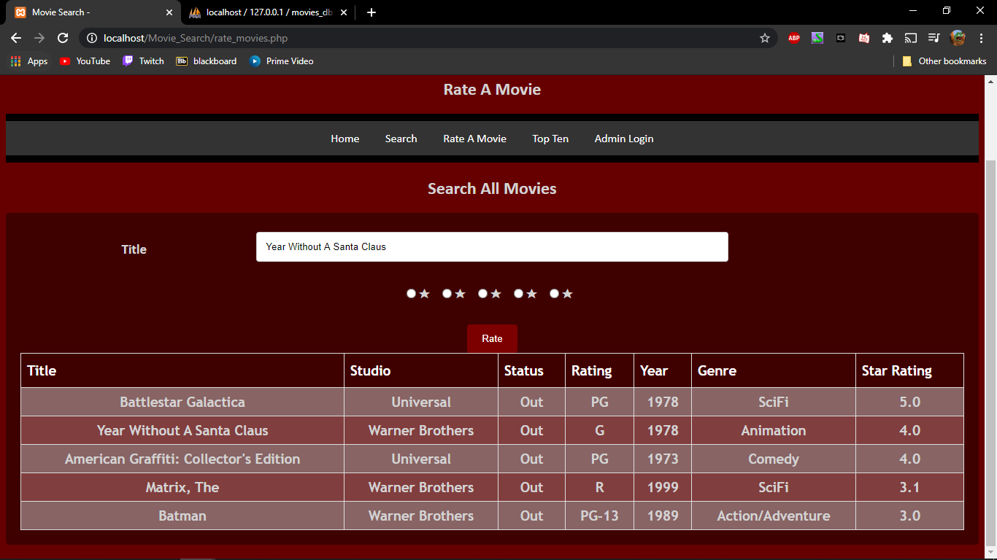

Figure 4

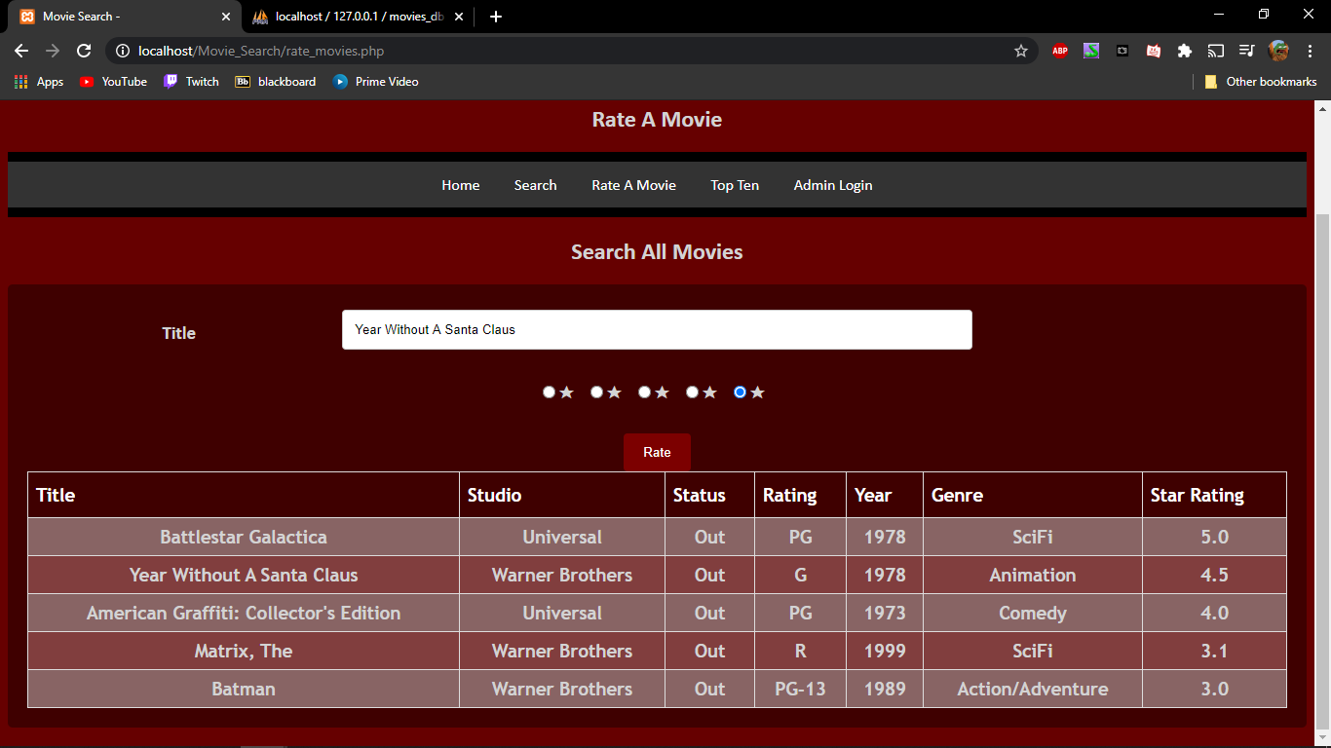

Figure 5.

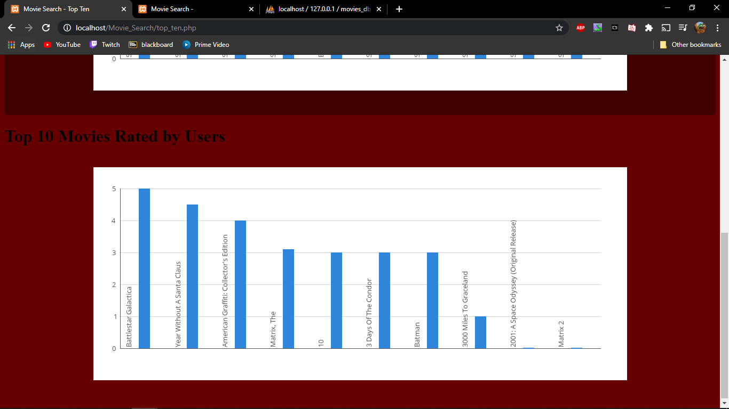

Figure 6.

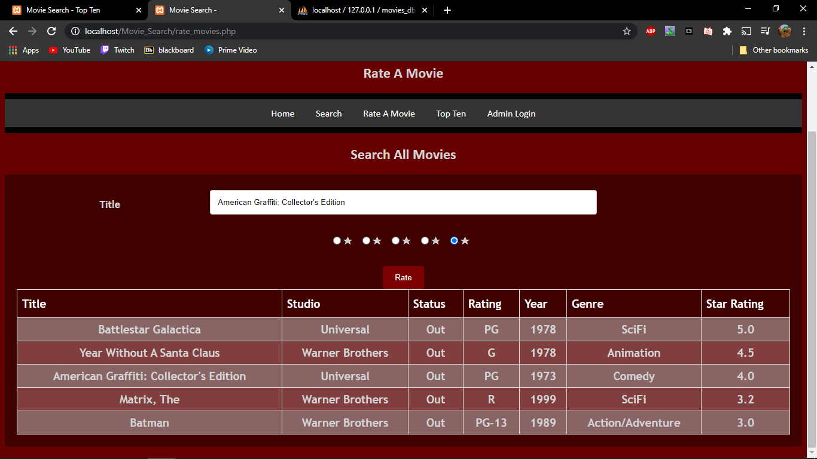

Figure 7.

